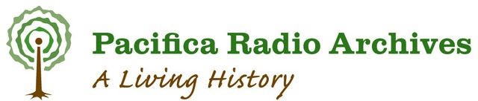

The PBCore Workshop at WGBH earlier this year was absolutely essential to the work we do here at the Pacific Radio Archives. I have been the Acting Director of the Pacifica Radio Archives for the last three years, and the Operations Director and Senior Producer since 1990. Just before I became Director, the Pacifica Radio Archive’s database was converted to PBCore. At that time I was not involved in the architectural metadata design of the PRA database.
The workshop was at times technical with an avalanche of terms, but at the same time, a thorough presentation on certain concepts like instantiation helped clarified a term that is essential to organizing a database.
I studied computer science and logic in college so I was right at home during the workshop. Still, there is quite a learning curve to understand the terms, how they relate to each other to make a powerful and robust database for a smooth user experience.
This workshop helped me understand on an introductory and practical level the logic and strategies that go into the data flow so that I can better direct future work that is done with our website and as we preserve, digitize and archive the remaining 50,000 tapes in our collection.

